**What is your project about? (A 1-2 word answer that describes your main focus, e.g., climate change)**

Beauty perception

**What is the data you plan to use? (A link to the dataset with one sentence describing it)**

[This](https://digitaluniversity.womendeliver.org/wp-content/uploads/2020/05/Mod-1-2017-Dove-Global-Girls-Beauty-and-Confidence-Report.pdf) dataset was a survey commissioned by Dove in 2017, with a possibility of comparing with other [surveys](https://www.clubofamsterdam.com/contentarticles/52%20Beauty/dove_white_paper_final.pdf) conducted previously to provide a time comparison.

| Element on page | Concept used | Weeks covered | Line number | File |
| --- | --- | --- | --- | --- |
| Quiz element e.g. “how many percent of girls feel high pressure to look beautiful?” with different elements. | JS elements like conditionals - if else for the quiz element (e.g. if button is pressed, go to next page; else, show window alert) | Week 3 - conditionals  Week 4 - seeing output from JS on your webpage | 39 | index.html |
| Events (e.g. onmouseover/onclick) | Week 5 | 39 | Index.html (and final project/appscripts/main.js |
| HTML and CSS elements like <h1>, <button>, background-color | Week 2 - HTML and CSS |  | final project/css/appstyle.css |
| Charts    Different views of the chart based on:   * Time - comparing data from the surveys conducted in 2017 and 2004 * Country - respondents in different countries   + Can change the view using a button or animation | Charts | Week 7 - linechart, barplots etc via chartjs. | 33, 45 | Index.html  (Charts located in final project/appscripts/main.js |
| Other interactive elements     1. Hover over a certain country to see more about beauty in that country and what type of country they are, according to the Dove report (e.g. traditionalist, modernist etc) and some pervasive beauty practices there 2. Animations on page (scrolling animations, loading animations) 3. Scroll animation/gif  (the dot drops from top to bottom on a loop on the [Kontinentalist](https://kontinentalist.com/stories/affordability-of-hdb-housing-policies-and-living-cost-for-low-income-singaporeans) page)   Animations to highlight/emphasize text on the page | Events (e.g. onmouseover) | Week 5 |  |  |
| Functions and objects | Week 4 |  |  |
| Loops | Week 6 |  |  |

Storyboarding

1. Problem statement
   1. We need to interrogate young women’s perceptions of beauty and self in order to combat the social and economic cost of poor self-perceptions.
2. Research question
   1. How do young women perceive themselves? What are the social, financial, and medical costs of poor self-perception?
3. How you found data
   1. [The 2017 Dove Global Girls Beauty and Confidence Report (Diedrichs and Weiner, 2017)](https://digitaluniversity.womendeliver.org/wp-content/uploads/2020/05/Mod-1-2017-Dove-Global-Girls-Beauty-and-Confidence-Report.pdf)
   2. [The Real Truth About Beauty: A Global Report (Etcoff et al., 2004)](https://www.clubofamsterdam.com/contentarticles/52%20Beauty/dove_white_paper_final.pdf)
   3. [The Real Cost of Beauty (Austin and Slaughter-Acey, 2022)](https://www.hsph.harvard.edu/striped/wp-content/uploads/sites/1267/2022/10/Real-Cost-of-Beauty-Report-10-4-22.pdf)
4. 1st data insight (with evidence) - why does this matter?
   1. Women face high pressures to look beautiful (7 in 10 girls with low body esteem feel pressure to be beautiful, 2017 p16)
   2. Can be attributed to increase in media consumption - reality tv can negatively impact self-perception of sexual attractiveness (<https://encompass.eku.edu/cgi/viewcontent.cgi?referer=&httpsredir=1&article=1049&context=etd>) and social media can correlate to eating disorders - the more the subjects compared themselves to the images, the more they increased their body dissatisfaction and their drive for thinness.
5. 2nd data insight (with evidence) - why does this matter? …
   1. Although girls feel there is excessive pressure put on them to be beautiful, they may engage in costly behaviours due to low self-esteem or self-confidence in their appearance
      1. Health/medical
         1. Electing to receive cosmetic surgeries which are medically unnecessary and bear significant risk (e.g. BBLs)
         2. Stopped eating, binged or skipped meals because they don’t feel good about the way they look (80% of girls with low self-esteem as compared to 30% of girls with high self esteem)
      2. Social
         1. missing out on social engagements and activities due to low self-esteem (2017, p.18) (80% of girls with low self esteem vs 40% with high self esteem)
         2. Being assertive in their opinion
      3. Financial costs
         1. Stakeholders like women, but also corporations and governments, bore heavy social and financial costs due to the prevalence of body dissatisfaction in the female population. In the US, the combined financial and well-being costs of severe body dissatisfaction in the US was estimated to be $305 billion in 2019. This includes $84 billion in financial costs and $221 billion in non-financial costs. The financial costs of body dissatisfaction comprised 0.4% of total US GDP in 2019.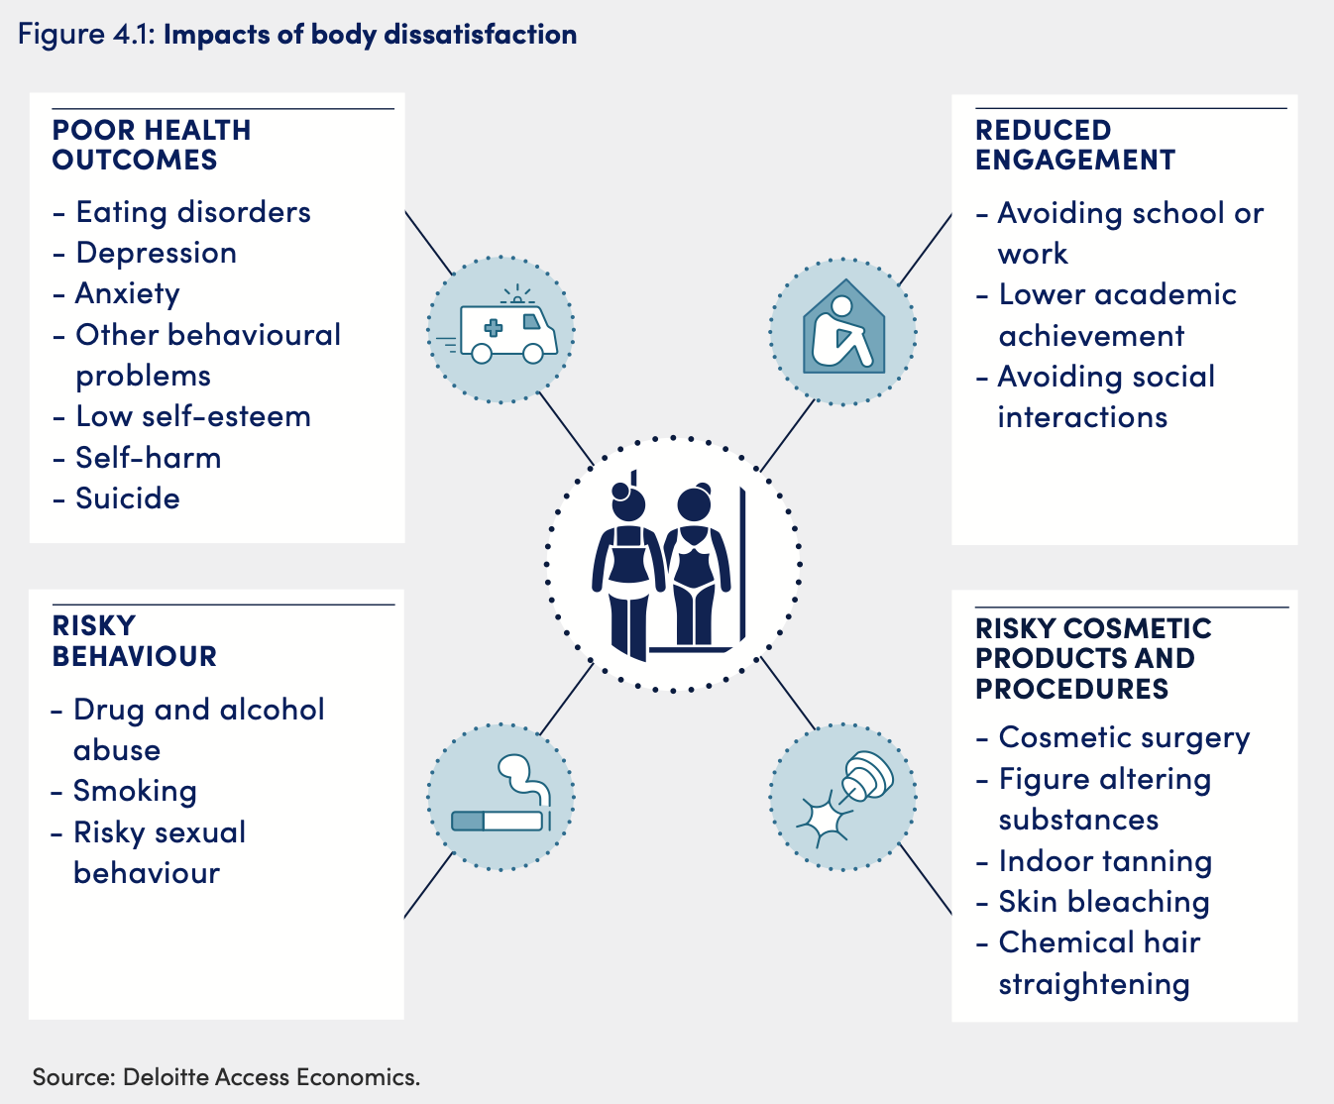
6. Resolution/recommendations
   1. improving media literacy - images that are photoshopped
7. Summary conclusion

